UT Soil, Plant, and Pest Center
5201 Marchant Dr. | Nashville, TN 37211 615-832-5850 | SoilLab@Tennessee.edu SoilLab.Tennessee.edu

Soil Testing Guide for Lawns and Gardens
Sample areas according to their management. Take ten “sub-samples” to comprise one composite sample from the management zone. Samples should be taken from the 0 to 6 inch depth. Place sub-samples into a bucket and mix well. After sample is well mixed, fill the soil box. If Texture is wanted, please fill two soil boxes. Label the box with your name and sample ID.
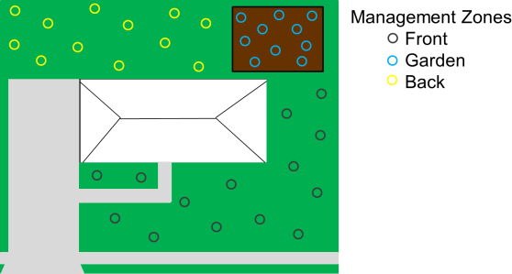
Figure 1. Sample by Management with about ten sub-samples comprising one sample from the area of interest. In this example, the front yard, back yard, and garden area are all sampled separately.
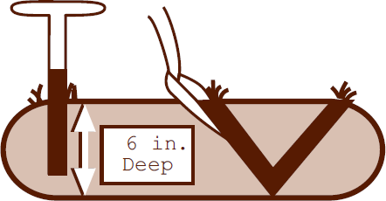
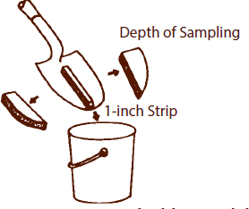
Figures 2 and 3. Sample 0 to 6 inches deep with probe or shovel. Images from UTIA Biosystems Engineering and Soil Science Department publication Soil Testing PB1061 by Hugh Savoy.

Fill out the submission sheet with corresponding information so the lab can match the sample to the sheet and payment. Please use the crop code to identify which plants or lawn species is intended to be grown.
Samples and payment may be shipped or dropped off at address above. Samples may be paid for by credit card (on-line at our website or over the phone), cash, or check. If paying by check, please make check payable to University of Tennessee.

Results and Recommendations will be sent by e-mail.

For more information please contact us at: 615-832-5850 or SoilLab@Tennessee.edu

